Unicellular and Multicellular Organisms
The structural and functional units of all living organisms are cells. Cells are the building blocks of life and all living organisms are made up of cells. In the human body there are about 100 trillion cells. The size of the cells is about 10 micrometre. Cells were discovered by Robert Hooke in 1665 using some early microscopes. Cells can be classified into two general types based on the way the cell is structured – Eukaryotic and Prokaryotic.
Prokaryotic cells are very simple and have no membrane bound organelles.
Eukaryotic cells are complex cells and have membrane bound organelles (like a nucleus) which have specialized functions.
Living Organisms can also be classified into two general types based on their size – unicellular and Multicellular.

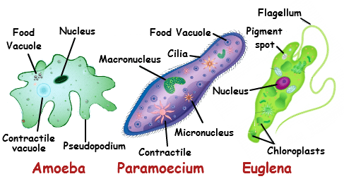
Unicellular Organisms (usually prokaryote)
Unicellular organisms are known as single-celled organisms. They are made up of a single cell which is generally a prokaryotic type of cell – so sometimes the terms unicellular and prokaryote are considered the same (but this is not scientifically correct). Unicellular organisms are the oldest forms of life, they existed about 3.8 million years ago. Bacteria, archaea, protozoa, and unicellular algae are the main groups of unicellular organisms. The single-cell regulates all the activity of the organism. Unicellular organisms are generally very small and are mostly invisible to the naked eye. The smallest organism are bacteria, only 300 nanometres long (0.0003 mm). Nutrition is usually by the process of phagocytosis, where the food particle is engulfed and stored in vacuoles present in the organism.
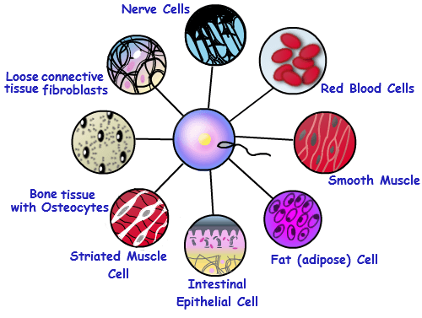
Multicellular Organisms
Multicellular organisms are made up of more than one cell and these cells are almost always eukaryotic cells. Most multicellular organisms are visible to the naked eye. They begin life as a single cell, but grow into multi-celled organisms.
Advantages of being a multicellular organism are that multicellularity allows the organism to be much larger. Multicellularity also allows greater complexity of the organism by allowing groups of cells to specialise and perform specific functions (digestion, circulation, brain etc). This means that parts of the organisms can be dedicated to specialized functions and together these parts can function far more effectively than single cell organisms. This can also be a weakness as the increasing complexity means there are more things that can go wrong
Plants, Animals, and Fungi are the three “kingdoms” of eukaryotes (multicellular organisms). Plants can make their own food from sunlight using chlorophyll, Fungi look like plants but don’t have chlorophyll so digest dead remains, and animals eat and digest food, move voluntarily and respond to stimuli quickly.
Differences between Unicellular and Multicellular Organisms

The main differences between unicellular and multicellular organisms are:
Unicellular Organisms | Multicellular Organisms
Body of the organism is made up of a single cell. | The body of multicellular organism is made up of numerous cells.
Body organization is simple. | Organization is complex.
The function of the whole organism is carried out by a single cell. | Specialized functions are performed by different cells, tissues, organs or organ systems.
Usually prokaryotic in nature. | They are mostly eukaryotic in nature.
The body of the cell is exposed to the environment on all sides. | Outer cells face the environment.
Any injury to cell can cause death of the organism. | Injury or death of some cells does not affect the organisms, the affected cells are replaced.
A limit is imposed to the size of the cell by the surface area to volume ratio and hence it can attain large size. | Due to multicellularity the organism can attain large size.
Lifespan of the organism is usually short. | Organisms have a longer lifespan.
Reproduction is by vegetative/asexual methods. | Reproduction is sexual type.
Has good capacity of regeneration and power of division. | Capacity of regeneration decreases with increase in specialization and certain cells that are specialized loose the power of division.
They are microscopic in nature. | They are macroscopic in nature.

